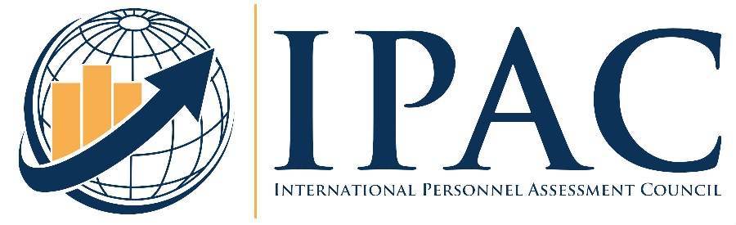

THE INTERNATIONAL PERSONNEL ASSESSMENT COUNCIL (IPAC)

ANNOUNCES
THE ANNUAL JAMES C. JOHNSON STUDENT PAPER COMPETITION (2024)

IPAC is offering the James C. Johnson Student Paper Award to recognize the achievements of students in the field of personnel management. Graduate, undergraduate, and former students are invited to submit research papers to be judged on the basis of their contribution to the field. The award winner will present the winning paper at IPAC’s Annual Conference in New Orleans, LA July 28-31, 2024. The winner will also receive up to $600 in conference related travel expenses, free conference registration, a one-year membership in IPAC, and recognition in the IPAC newsletter. In addition, the University Department where the student’s research was completed will receive a plaque commemorating the student’s IPAC award achievement.

Competition Rules
Papers must be theses, dissertations, published or unpublished research, or other student papers that describe original research conducted by the author while a student. Papers submitted must have been written within two years of the entry deadline, may not have been previously submitted to this competition, and must have been written as a student. Papers should address either substantive or methodological issues in areas such as the following:

- Personnel Selection
- Employment Tests
- Job Analysis
- Employee Performance Evaluation
- Assessment of Productivity or Organizational Effectiveness
- Assessment of Training Outcomes
- Other Related Topics

Deadline
All manuscripts for the 2024 competition must be e-mailed no later than April 8, 2024 to Dr. Christopher Nye at nyechris@msu.edu

Procedure for Submission
- The following must be included with each entry in order to be accepted:

- A completed competition cover sheet (see the following page)
- An electronic version (soft copy) of the paper

B. Submissions are not to exceed 25 double-spaced pages of text (not including references or tables.)

All papers should include a description of each of the following:

1. The research problem
2. Methodology
a. Sampling
b. Instruments used
3. Data analysis
4. Findings/conclusions

Judging of Entries
The papers will be reviewed anonymously by a panel of academics and practitioners. Papers will be judged on their contribution to the field of personnel assessment, including an evaluation of their scientific merit as well as the degree to which the research addresses issues of practical importance to the field of personnel assessment.

Award
- The winner will present their paper at the 2024 IPAC Conference
- Up to $600 reimbursement for travel to the conference
- Free conference registration
- Free one-year IPAC membership
- Recognition in IPAC’s newsletter
- Plaque to commemorate winner’s achievement
Please e-mail this cover sheet and your paper submission
directly to Dr. Christopher Nye, nyechris@msu.edu

Deadline: April 8, 2024

2024 JAMES C. JOHNSON STUDENT PAPER COMPETITION
COVER SHEET

Name ___________________________________________________________________________________

Address__________________________________________________________________________________

_________________________________________________________________________________

_________________________________________________________________________________

Daytime Telephone Number (______) ______ - _____________

E-mail: _____________________________________________

College or University where paper was done. (Indicate whether graduate or undergraduate).

_________________________________________________________________

_________________________________________________________________

Date paper was completed __________________________________________________

Title of paper_____________________________________________________________________________

_____________________________________________________________________________

Who else worked with you on this paper and in what capacity? (Include your advisor’s name)

_____________________________________________________________________________

I certify that the paper being submitted represents my own original work and that I was primarily responsible for the
research design and execution of the research described therein. I also understand that presenting this paper at the IPAC
conference is as important a factor in being the Student Paper Competition winner as having been selected as the winner.
Therefore, if my paper is selected as the winner, I will prepare a presentation based upon it to be given by myself in-
person at the IPAC Conference in New Orleans, LA July 28-31, 2024. In turn, I will make all necessary arrangements to
present my paper in-person whenever it is scheduled at the conference.

______________________________________________ _____________________________
Signature Date

